Investigation
First read all of the online resources and use the student resource sheet to help you carry out an investigation of the geography of the 2016 Welsh Government Election. Use it to formulate questions which you can follow up after the results are in for the 2016 vote in May and your own surveys/mock elections of your class, year group or whole school.

- Introduction
  - In this section you will explain what it is that you are investigating.
  - You will choose questions for enquiry that you want to answer.
  - You will explain important background information.
  - Outline a plan of what you intend to do and what data you will collect.

- Results
  - Tabulate (put in tables) data.
  - Convert the data into easier forms to interpret:
    - Use graphs
    - Simplify data into things like rounded numbers or a representative mean.

- Analysis
- Show how your results answer your questions for enquiry:
  - Annotate graphs and diagrams
  - Construct paragraphs.

- Conclusions
- For each of your enquiry questions what have you found out? What is the answer?

- Methodology
- Often the Methodology follows the Introduction as you explain what you plan to do. In this investigation we are going to place the Methodology before the Evaluation so that we can better develop our evaluative skills for the future.
- You will explain how you gathered your data and justify your choices.
- You will explain how you represented your data and justify your choices.

- Evaluation
  - Evaluate your process (how you carried out your investigations (methods)) – what was successful? What went wrong? What could you do differently next time?
  - Evaluate your sources – (your information and data) which are reliable and why? Which might be biased and why?
  - Evaluate your outcomes – (your conclusions) what is reliable and why? Which may be wrong or inaccurate and why?
  - Formulate more questions for a future enquiry based on your findings; this is especially important to find out if your predictions may be correct after the election.
- Put the section title Introduction.

- What is the Welsh Government?

- What is the National Assembly for Wales?

- Since 2007 what is the role of:

- The Welsh Government?
- The National Assembly for Wales?

- What is an election?

- Who can vote in the May National Assembly election?

- What areas of power are devolved the National Assembly for Wales?

- Research each the six main parties taking part in the 2016 Assembly elections. Give a brief descriptions of main ideas of each:
  - Labour
  - Conservative
  - Plaid Cymru
  - Lib Dem
  - Greens
  - UKIP

- Put a subheading Questions for Enquiry.
- Devise some questions for enquiry use these but also add two of your own.
  - What patterns exist in Wales of where different parties have more seats?
  - Have these patterns changed since 1999?
  - Are there differences between my class and the constituency where I live?
  - ?
  - ?

- Put the section title Results.

- Draw up small table for each party with two columns – FOR and AGAINST.

For | Against

- Rank each of the parties in the order that you would vote for them.

- Carry Out a class mock election where everyone has a single vote to pick a first past the post party winner. Record your results in a table.
Party | Votes | %
Labour
Conservative
Plaid Cymru
Lib Dem
Green
UKIP

- Draw a bar graph to show your class results.

- Work out the percentages of votes cast for each party.

- Draw a pie chart based on the % values that you work out.

100 ÷ Total number of votes x Number of votes for each party

- Compare how your class compared to the 2011 results and then the 2016 results after the election.

2011 Election Results |  | Constituency Seats |  |  | Regional Seats |  |  |  | Total
Parties |  | Votes | Seats | Votes |  | % | Seats | Total |  | %
 | Labour | 401,677 | 28 | 349,935 |  | 36.9 | 2 | 30 |  | 50.0
 | Conservative | 237,388 | 6 | 213,773 |  | 22.5 | 8 | 14 |  | 23.3
 | Plaid Cymru | 182,907 | 5 | 169,799 |  | 17.9 | 6 | 11 |  | 18.3
 | Liberal Democrats | 100,259 | 1 | 76,349 |  | 8.0 | 4 | 5 |  | 8.3
 | UKIP | N/A | 0 | 43,756 |  | 4.6 | 0 | 0 |  | 0.0
 | Green Party | 1,514 | 0 | 32,649 |  | 3.4 | 0 | 0 |  | 0.0
 | Independent | 12,478 | 0 | 1,094 |  | 0.1 | 0 | 0 |  | 0.0

- For the elections in 1999, 2003, 2007 & 2011 draw graphs to show total number of seats for each party.

1999
Labour 28
Plaid 17
Conservative 9
Libs 6

2003
Labour 30
Plaid 12
Conservative 11
Libs 6
Independent 1

2007
Labour 26
Plaid 15
Conservative 12
Libs 6
Independent 1
2011
Labour 30
Plaid 11
Conservative 14
Libs 5

- Describe any changes you notice in your results graphs.

- Look at the different maps showing constituency seats in each election. Describe the pattern using the following prompts:

- What is the most popular party in North Wales?

- What is the most popular party in Mid and West Wales?

- What is the most popular party in South Wales Central?

- What is the most popular party in South Wales East?
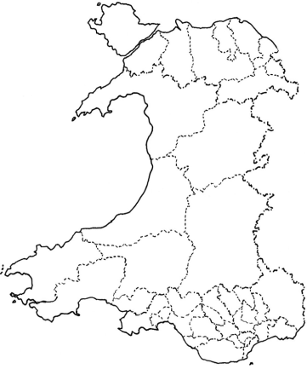
- What is the most popular party in South Wales West?

- Look at the maps of the results. Describe any pattern that you can see in where seats are changing.

- Use outline maps to show changes in regional seats during each elections. 1999 has been done for you in the online resource.

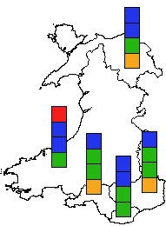

- For the actual 2016 election; draw a table to show the actual 2016 results.

Party | Votes
Labour
Conservative
Plaid Cymru
Lib Dem
Green
UKIP

- 2016 results draw a graph to show the actual 2016 results. Find these out after the election from a news website.

- Complete a map to show 2016 regional results.

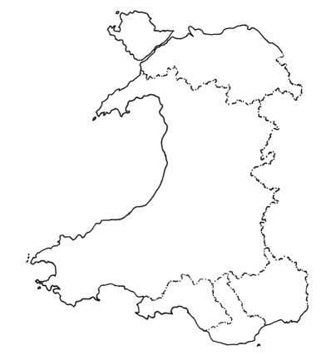

- Complete a map to show the 2016 constituency results.

- Give every map and graph a title and a number such as Map 1, Map 2, Graph, Graph2, Table 1, Table 2 until each one has a number.

- Put the section title Analysis.

- Put at least one piece of annotation on each map and graph. An annotation is a piece of writing on or near a diagram which is more detailed than a label.

- You are going to practice a skill called cross referencing. You are going to write some short paragraphs by referring to your maps and graphs. Such as:

In map 1 you can see……………..
Graph 3 shows that ……………………

- Use cross referencing to help you write a paragraph about where different parties get their most seats.

- Use cross referencing to help you write a paragraph about if there has been any changes in where a party wins its seats over time (1999 -2011 (and 2016).

- Use cross referencing to help you write a paragraph about if there is any difference between how you and your class votes compared to your constituency and also Wales as a whole.

- Put the section title Conclusions.
- In question 10 you devised some questions for enquiry; answer each question.
  - What patterns exist in Wales of where different parties have more seats?
  - Have these patterns changed since 1999?
  - Are there differences between my class and the constituency where I live?
  - ?
  - ?

- Put the section title Methodology.

- Describe how you obtained information from:
  - Primary sources such as carrying out a mock election or carrying out a survey (opinion poll)
  - Secondary sources (information collected by other people.

- For each type of map or graph that you produced say why you think it was a good choice to show the information.

- Put the section title Evaluation.

- Evaluate your process (how you carried out your investigations (methods)) – what was successful? What went wrong? What could you do differently next time?

- Evaluate your sources – (your information and data) which are reliable and why? Which might be biased and why?

- Evaluate your outcomes – (your conclusions) what is reliable and why? Which may be wrong or inaccurate and why?

- Formulate more questions for a future enquiry based on your findings; this is especially important to find out if your predictions may be correct after the election.

- Extension activities use data from a wider school mock election either first past the post by class or first past the post plus a second vote (regional vote) by year group:

  - Whole Year Group
  - Whole Key Stage
  - Whole School

